KJEI’s
K J College of Engineering & Management Research Pune
Department of Electronics and Telecommunication Engineering



List of live MOUs:
Academic Year 2024-2025
Sr No | Name of Industry | Duration | Date of MOU signed
1 | CII NexGen Mobility Show 2024, Moshi, Pune | 3 Years (from 16/8/2024 to 15/8/2024) | 16/8/2024

Academic Year 2023-2024
Sr No | Name of Industry with address | Duration | Date of MOU signed
1 | Do IT INFOSYSTEMS  512/C Ajinkya Plaza,  Ajinkya Colony, Satara 415 001 | 5 Years (From 14/07/2023 to 13/07/2028) | 14/07/2023
2 | AEROSYS, HVDC SOLUTION LLCUAQ(UAE)  PO Box: 2611, UAQ(UAE) | 5 years  (from 29/11/2023 to 28/11/2028) | 29/11/2023
3 | ECE INDIA ENERGIES PRIVATE LIMITED,  Plot No. F-27  Amravati MIDC Area, Express Highway NH-06, Amravati 444 607  Corporate Sale Office:  2nd Floor, Navle Icon, Near Navle Bridge, Pune 411 041 | 5 years  (from 13/10/2023 to 12/10/2028) | 13/10/2023
4 | Industry: AMB’s C-DSP,  #H.O.: Plot No.13, Renukanagar, Near Mayureshwar Ganesh Temple,  Deolai Area, Chhatrpati Sambhajinagar-431010 Maharashtra State  #Factory: (Production):  B-29 MIDC Ambad Dist. Jalna | 3 years (from13/04/2024 to 12/04/2027) | 13/04/2024
5 | Technouniq  Engineering Intelligence  105 & 106, Sigma House, SB Road, Pune 411 045 | 5 Years (19/04/2024 to 18/04/2024) | 19/04/2024

Academic Year 2022-2023
Sr No | Name of Industry | Duration | Date of MOU signed
1 | Bag Electronics  S. No. 19, Kondhwa Road, Yewalewadi  Tal. Haveli, Dist. Pune | 5 Years (from 01/11/2022 to 31/10/2027) | 1/11/2022

Academic Year 2021-2022
Sr No | Name of Industry | Duration | Date of MOU signed
1 | iBase Electrooft LLP,  Mudholkar Peth Amravati 444 601 | 5years (01/07/2021 to 30/06/2026 | 01/07/2021
2 | Palp Technologies,  B-1501,15th floor, Girnar 108, Ganga Dham-Shantrunjay Road, Kondhwa, Pune 411 048 | 5 Years (from 05/07/2021 to 04/07/2026) | 05/07/2021

Activities conducted under the MOU:
AY 2024-2025
Sr. No. | Details of MOU | Duration | Activity Conducted | Date | Resource Person
1 | CII NexGen Mobility Show 2024, Moshi, Pune | 3 Years (From 16/8/2024 to 15/8/2027 | Industry Visit  TE (E&TC)  Students: 38  Faculty: 2 | 18/10/2024 | Mr. Vishal Lal
2 | CII NexGen Mobility Show 2024, Moshi, Pune | 3 Years (From 16/8/2024 to 15/8/2027 | Expert Lecture on Turning an Idea into a Product-The Entrepreneurship way | 15/10/2024 | Prof.Bharat Oswal

AY 2023-2024
Sr. No. | Details of MOU | Duration | Activity Conducted | Date | Resource Person
1 | Do IT INFOSYSTEMS  512/C Ajinkya Plaza,  Ajinkya Colony, Satara 415 001 | 5 Years (From 14/07/2023 to 13/07/2028 | One day workshop on Digital Marketing | 20/04/2024 | Mr. Sanket Gharge
2 | Do IT INFOSYSTEMS  512/C Ajinkya Plaza,  Ajinkya Colony, Satara 415 001 | 5 Years (From 14/07/2023 to 13/07/2028 | Seminar | 14/07/2023 | Mr. Sanket Gharge
3 | Palp Technologies,  B-1501,15th floor, Girnar 108, Ganga Dham-Shantrunjay Road, Kondhwa, Pune 411 048 | 5 Years (from 05/07/2021 to 04/07/2026) | Seminar on Solar energy and application | 03/09/2023 | Mr. Pritam Balgat

AY 2022-2023
Sr. No. | Details of MOU | Duration | Activity Conducted | Date | Resource Person
1 | Bag Electronics  S. No. 19, Kondhwa Road, Yewalewadi  Tal. Haveli, Dist. Pune | 5 Years (from 01/11/2022 to 31/10/2027) | Industrial Visit, Second Year and Third Year Engineering Students | 29/04/2023 | --
2 | iBase Electrooft LLP,  Mudholkar Peth Amravati 444 601 | 5years (01/07/2021 to 30/06/2026 | Seminar on Application Development using python with ML | 03/08/2022 | Mr. Nakul Deshmukh

AY 2021-2022
Sr. No. | Details of MOU | Duration | Activity Conducted | Date | Resource Person
1 | Sunclipe technologies,  Sainagar Sukhsagar ,Pune | 5 Years (from 01/07/2016 to 30/06/2021) | Webinar on Python Programming Foundation | 18/08/2021 | Mr. Sachin Tikle
2 | Infistics Solutions Pvt.Ltd.  Hadapsar, Pune | 5years (03/10/2016 to 30/09/2021 | Webinar | 23/06/2021 | Mr.Chittaranjan Mahajan

AY 2020-2021
Sr. No. | Details of MOU | Duration | Activity Conducted | Date | Resource Person
1 | Circuithub Electronics, Pune | 5 Years (from 22/06/2021 to 22/o6/2022) | Webinar on Importance of Skillsets in Career | 31/08/2020 | Mr. Pranesh Dhoka
2 | Circuithub Electronics, Pune | 5 Years (from 22/06/2021 to 22/o6/2022) | Webinar on New Embedded Environment and its application | 25/07/2020 | Mr. Aditya Sabnis

AY 2024-2025
On 18/10/2024 , Industry visit: CII NexGen Mobility Show 2024, Moshi, Pune.TE students

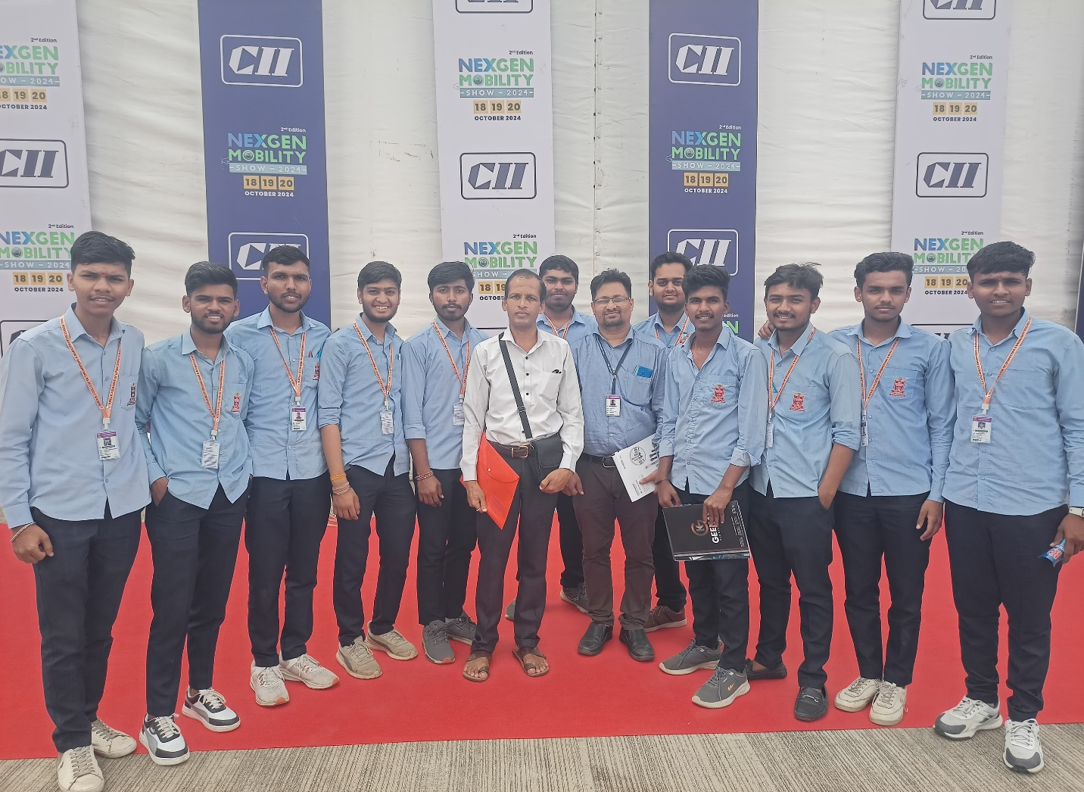
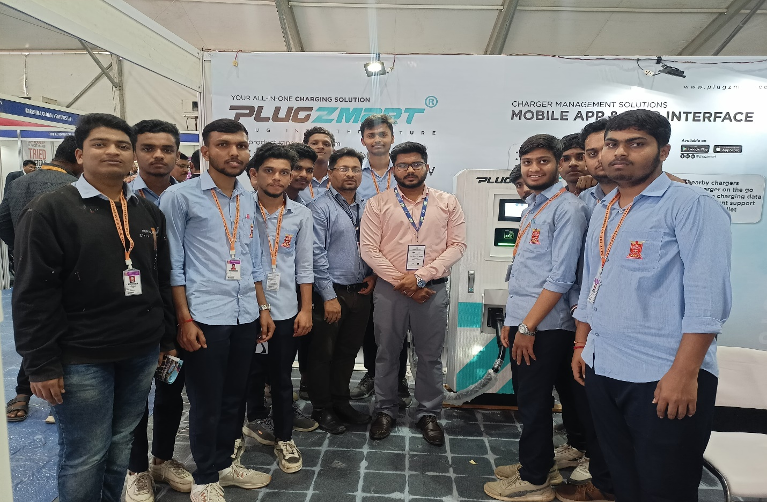

On April, 2024, from 9:15 AM to 5:00 PM, the Electronics and Telecommunication Engineering KJCOEMR, Pune, organized a technical session on Java full stack development for third year and final-year engineering students. The session was led by Mr. Sanket Gharge, founder of India Farmer Entrepreneurs and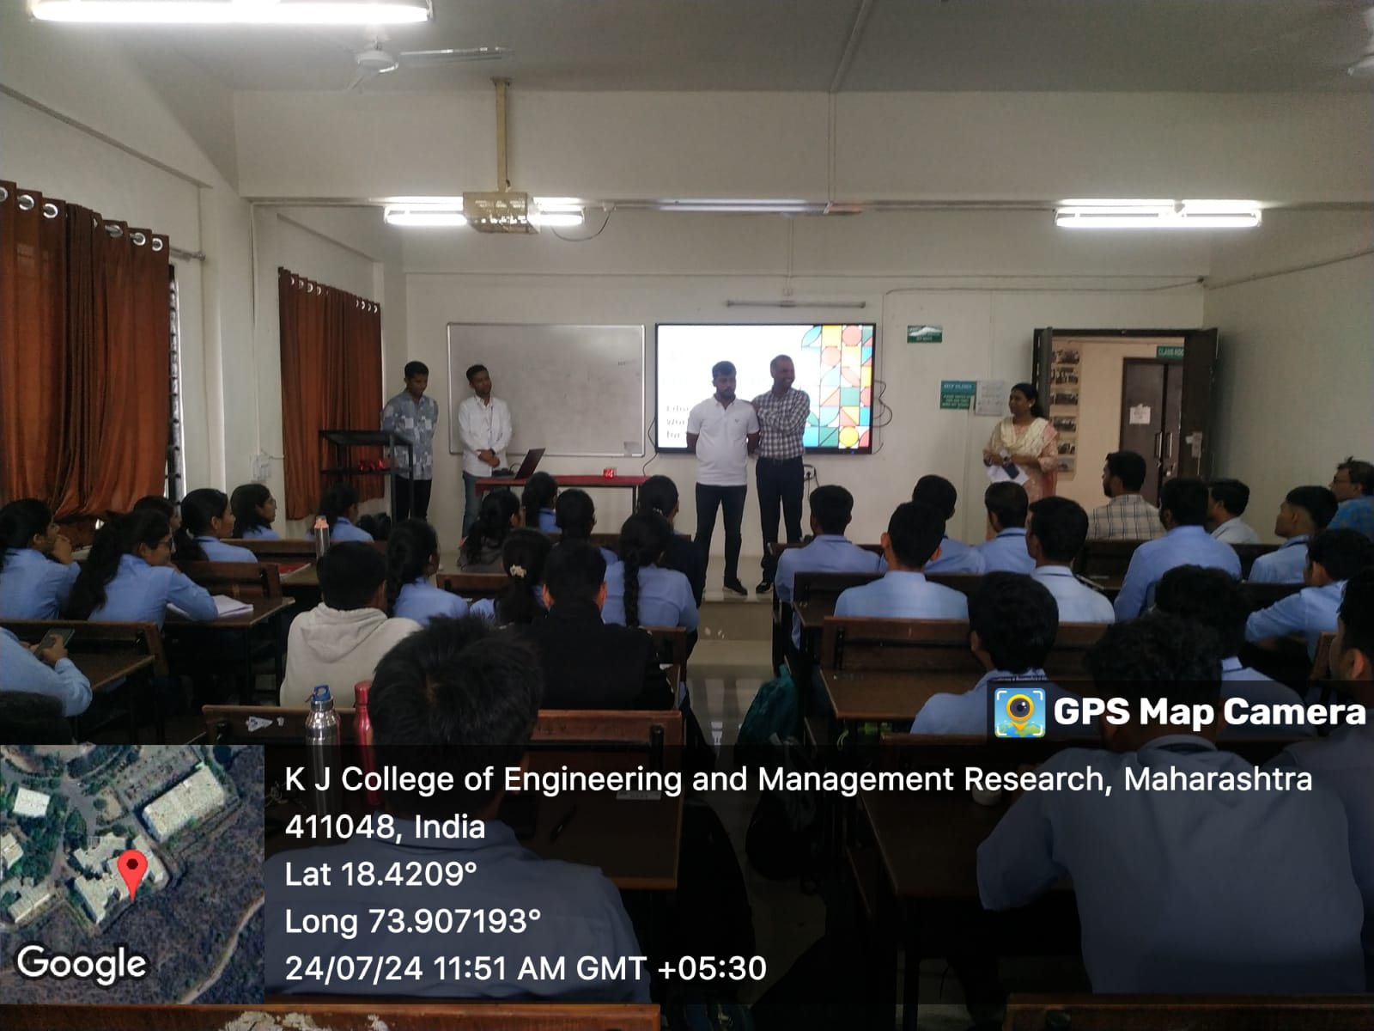 the IFE Store, Satara
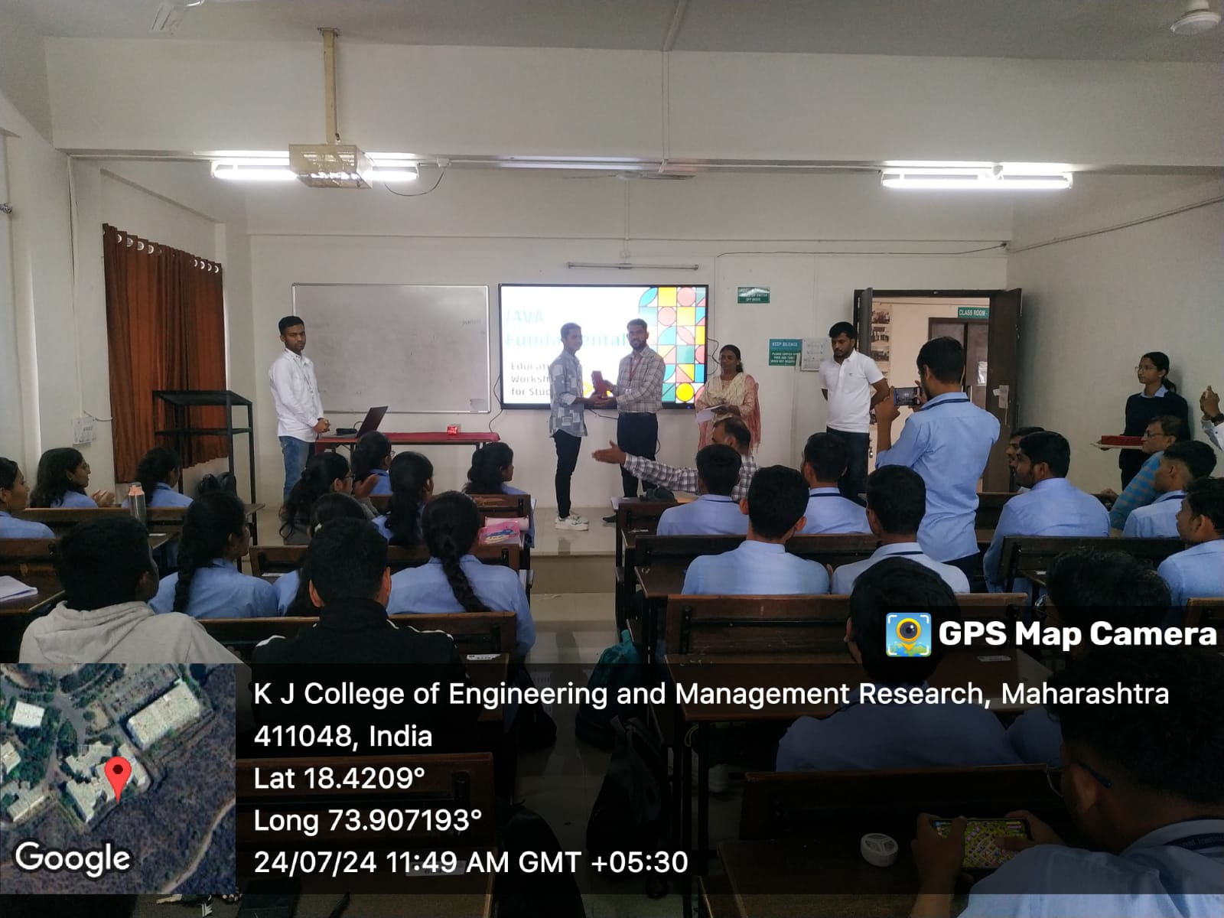
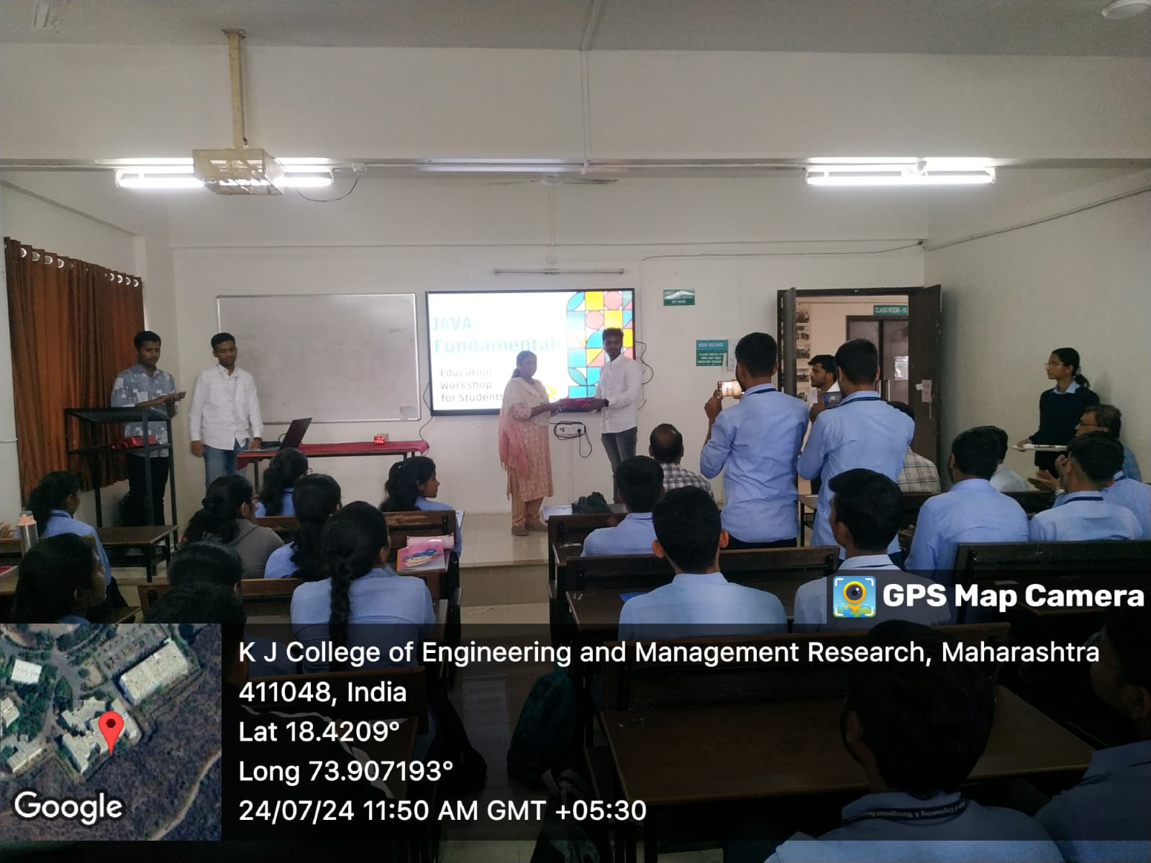
AY 2023-2024
On April 20, 2024, workshop on digital marketing for final-year engineering students. The session was led by Mr. Aniket Gharge, founder of India Farmer Entrepreneurs and the IFE Store, and Mr. Sahil Mulla, founder of Tara Media Works, Satara
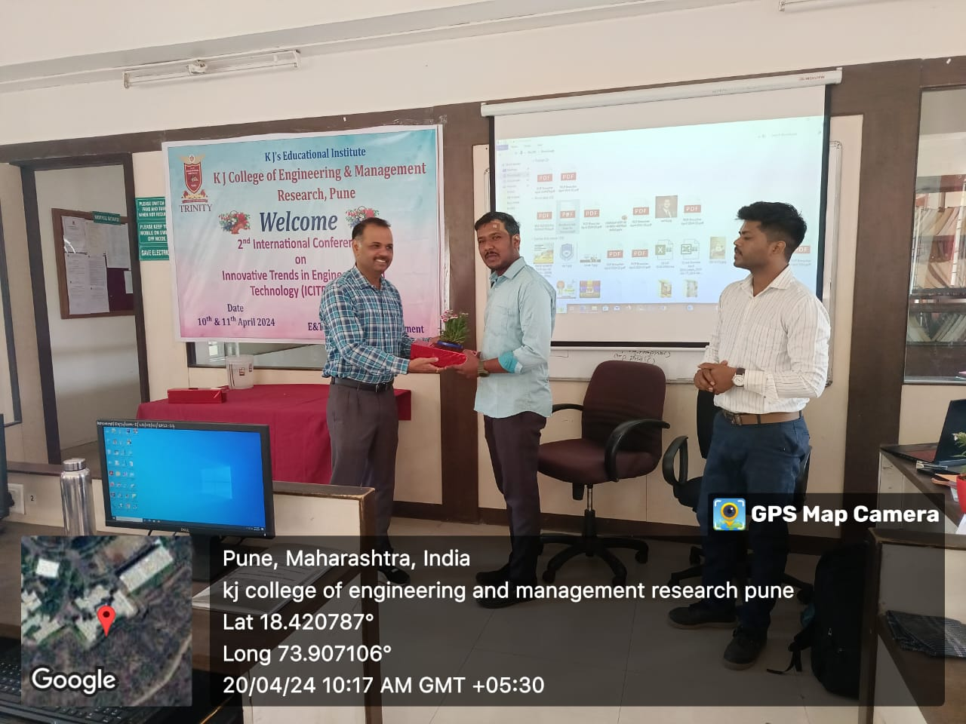
Dr Pramod Chavan HOD E & TC felicitated Resource person Mr. Aniket Gharge founder of India Farmer Entrepreneurs and the IFE Store

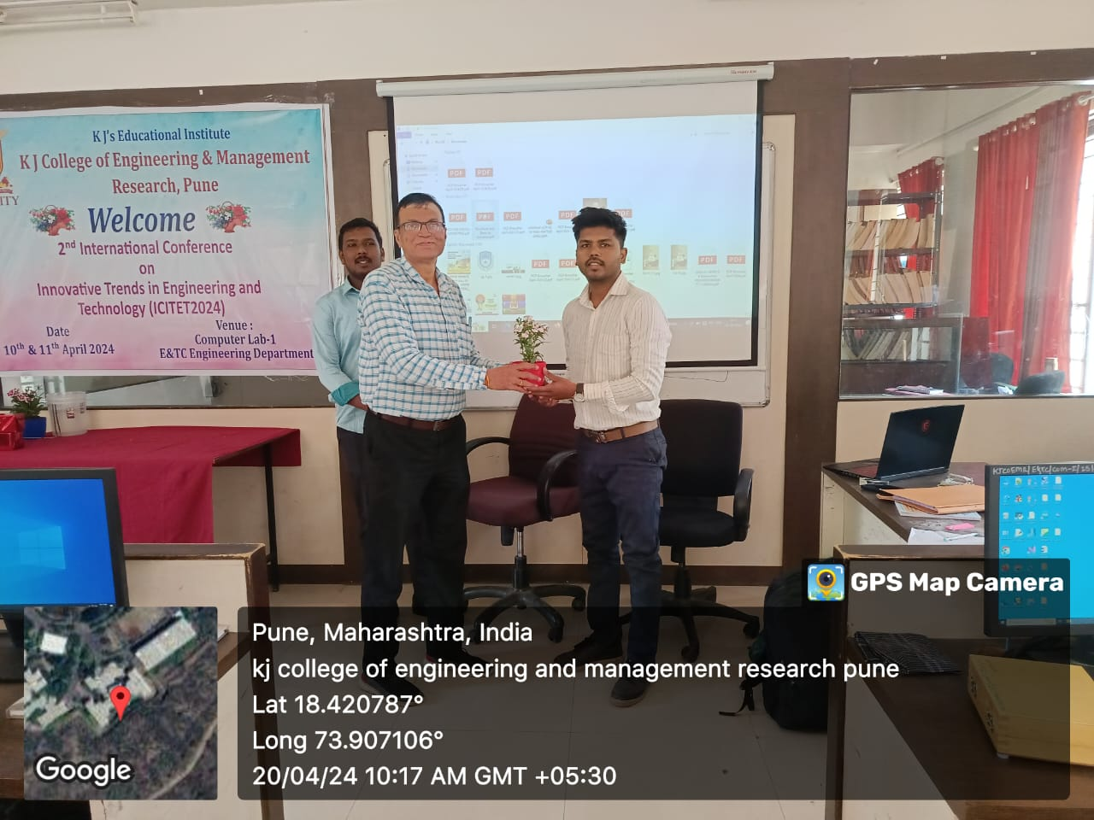
Dr. R.G.Zope, Associate Professor felicitated Resource person Mr. Sahil Mulla founder of Tara Media Works.
Images of student participated in the session

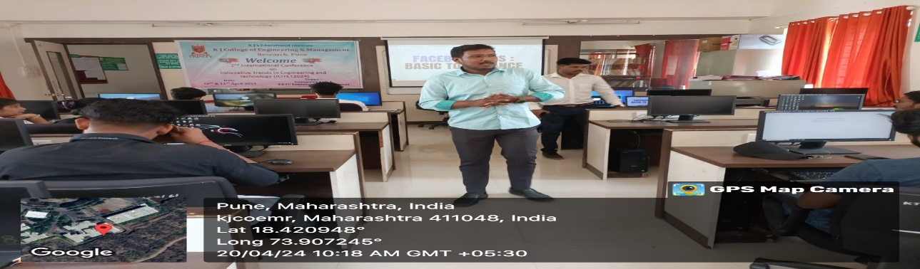
Mr. Sahil Mulla Conducted hands-on training on Digital Marketing to final engineering students.

AY 2022-2023
On19 September, 2023, from 10.00 AM to 11.00 AM, the Electronics and Telecommunication Engineering KJCOEMR, Pune, organized an expert lecture on “Solar pump controller” for second year and third -year engineering students. The expert lecture was delivered by Mr. Pritam Bhalgat Palp Technologies, Pune.

