COEP Mentorship Programs (2022-23 , 2023-24)
Year 2023-24:
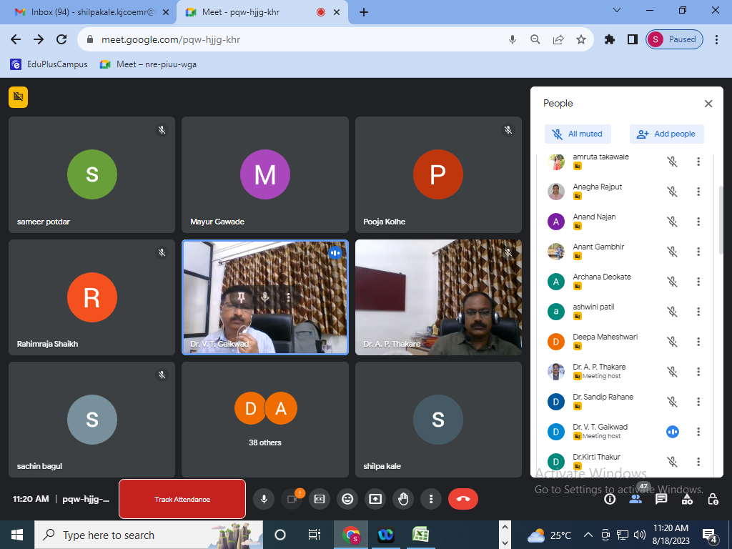
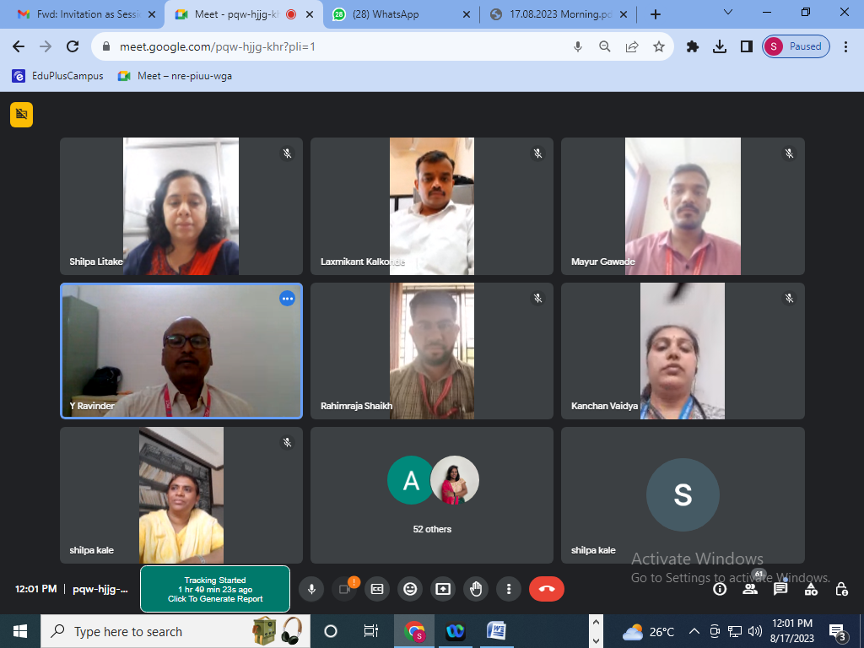
Prof. Suhas Kakde ,COEP Technological University ,speaker for the ISTE approved One Week STTP On “Future Trends in 5G and 6G Challenges, Architecture, and Applications” (16th August to 20th August 2023).

Year 2022-23:
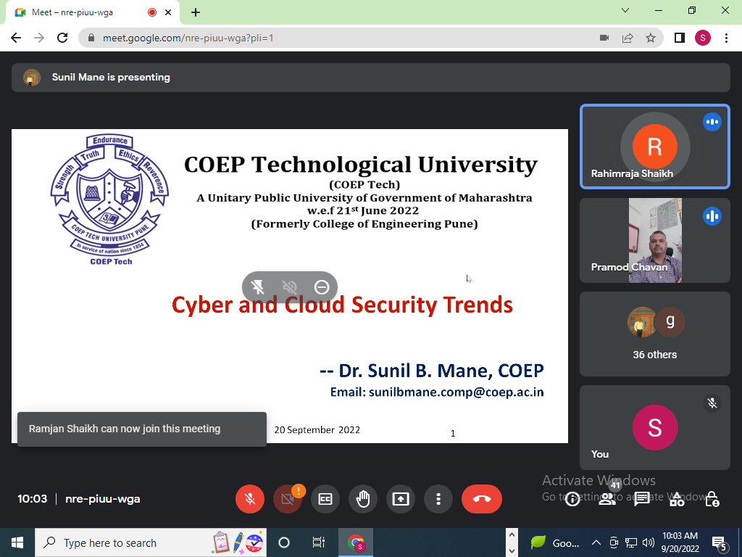
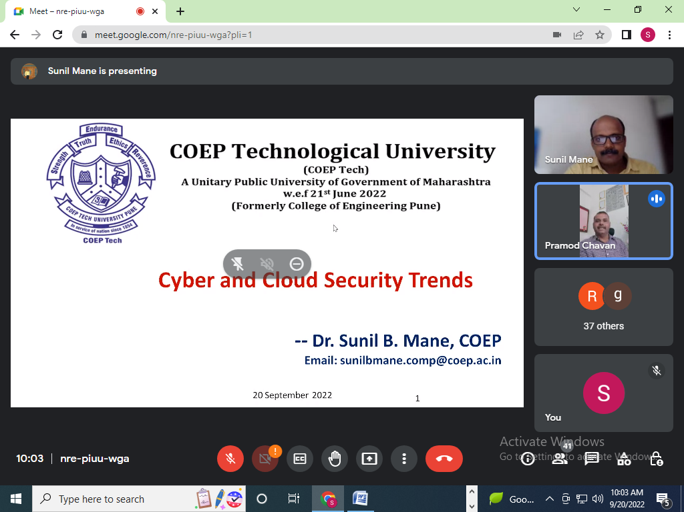
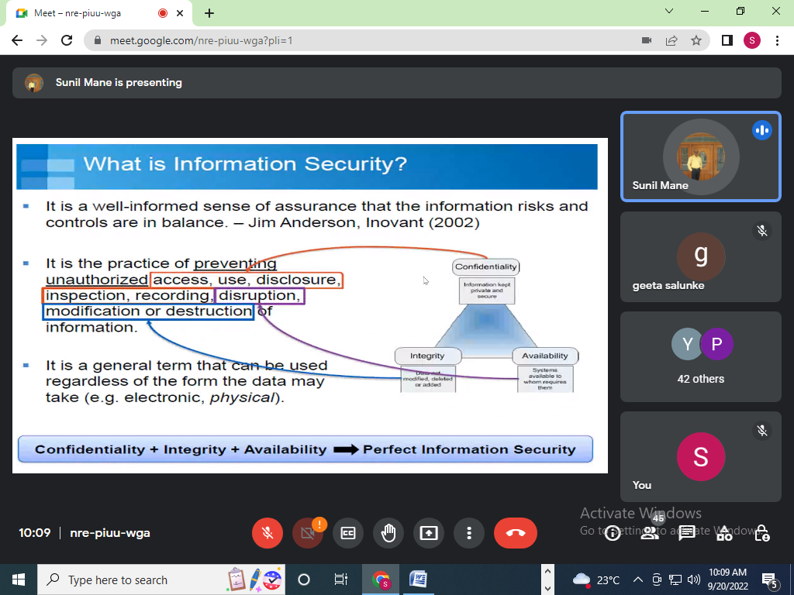
Dr. Sunil B. Mane COEP Technological University ,speaker for the ISTE approved One Week STTP on “Cloud Computing Using-Amazon Web Services and Google Cloud Platform” (19th September to 23rd September 2022) in Online mode.

